1. **What is GIT?**

An Open-Source software configuration management (SCM) tool used for Version controlling to facilitate the tracking of changes in projects and promote team collaboration.

1. **So what is Version Control?**

VC refers to Is the management of changes to documents, computer programs, large websites, and other collections of information. Can be:

* Centralized VCS or
* Distributed VCS

1. **How does Version Control Work?**

It permits developers to track and keep named versions of changes they are working with.

1. **Why do we need a Version Control in IT Services?**

* To keep track of changes as they are made on projects
* To provide referrals and rollback points if errors arise instead of restarting projects completely
* To facilitate troubleshooting for big data
* Promote simultaneous collaboration for team
* Speed up work as different people could work on the same project remotely.
* Promote professionalism

1. **How did we keep tracks of changes on projects before?**

JAVA.NET

1. **What happened to it?**

Account closed by the host.

1. **Alternatives of Version Controls?**

* Mercurial
* SharePoint
* TFS
* Git

**Comparison of different well known version controls**

|  |  |  |  |  |
| --- | --- | --- | --- | --- |
| **FACTORS** | **Git** | **Svn/Java.net** | **SharePoint/** [**Team Foundation Server**](https://en.wikipedia.org/wiki/Visual_Studio_Team_Foundation_Server)**(TFS)** | **Mercurial** |
| **Credibility worldwide** | Very credible. Used by Google, Facebook, BMW,IBM, | Was very credible but closed | Fairly Credible but less used worldwide. | Fairly Credible but less used worldwide. |
| **language** | Cross-compatible to C, Perl, Shell scripts | Only used for Java platforms. | Only for Microsoft | [Python](https://en.wikipedia.org/wiki/Python_(programming_language)), [C](https://en.wikipedia.org/wiki/C_(programming_language)) |
| **Cost** | Free | free | Need Microsoft license for deployment unless used for Open source projects. | free |
| **Storage methods** | Snapshot | Change-set and Snapshot | Change-set | Change set |
| **Repository model** | Distributed | Centralized | Distributed, Client-Server | distributed |
| **Supported platforms** | [POSIX](https://en.wikipedia.org/wiki/POSIX), [Windows](https://en.wikipedia.org/wiki/Microsoft_Windows), [OS X](https://en.wikipedia.org/wiki/OS_X), cross-platform via [Visual Studio Team Services](https://en.wikipedia.org/wiki/Visual_Studio_Team_Services) | [Unix-like](https://en.wikipedia.org/wiki/Unix-like), [Windows](https://en.wikipedia.org/wiki/Microsoft_Windows), [OS X](https://en.wikipedia.org/wiki/OS_X) | [Windows](https://en.wikipedia.org/wiki/Microsoft_Windows), cross-platform via [Visual Studio Team Services](https://en.wikipedia.org/wiki/Visual_Studio_Team_Services) | [Unix-like](https://en.wikipedia.org/wiki/Unix-like), [Windows](https://en.wikipedia.org/wiki/Microsoft_Windows), [OS X](https://en.wikipedia.org/wiki/OS_X) |
| **Security** | [SHA-1](https://en.wikipedia.org/wiki/SHA-1) hashes | Numbers | Numbers | Numbers, [SHA-1](https://en.wikipedia.org/wiki/SHA-1) hashes |

Note: latest Git 2.13 improves security by:

* Providing the ability to handle multiple identities through conditional configurations. ***Conditional configuration*** provides a way to include a Git config file based on a set of conditions.
* Provide One Drive support for cloud storage of about 60GB repo thus no need to pay at GitHub for a personal repo. Git uses git-annex plugin to achieve this.

**Why use Git?**

* Git uses a ***Distributed repository model***. – Git is locally enabled. Thus work continues even offline. Complexity of server requirement setup needed.
* Open source
* Git tracks state, history and integrate of the source tree
* Git will not use much bandwidth you don’t have to connect with your server always you just need to connect to push code when you are done
* Reduced cost of data as you can work offline after the entire cloning of master repos to local branches.
* No loss of committed data. Even if they are deleted from recycle bin. Can still be recovered
* Developers have full control on commands that they want. They can even customize their files and project to suit them. For example, you can merge selected segment of different works done by different people instead of merging the entire versions of different people to make a new version.
* Very easy to use. You do not need programming expertise to use it.

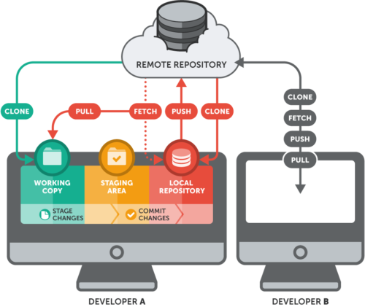

1. **Centralized version control model**

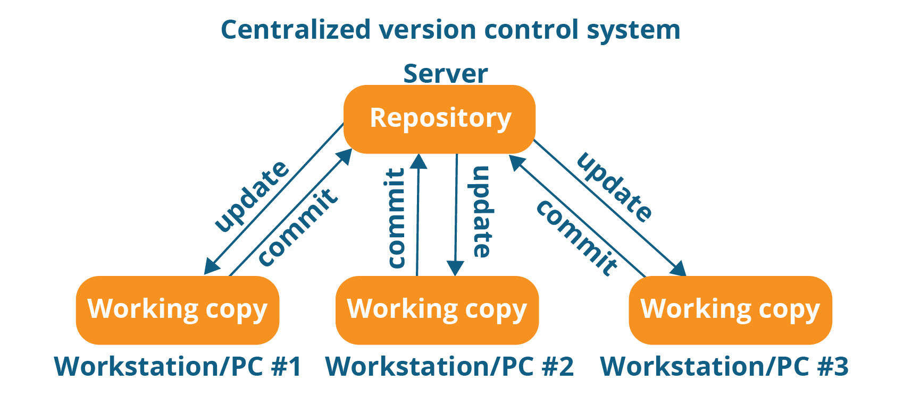

Examples of Centralized version control systems are SVN, CVN, Dazaar etc.

1. **Distributed version control model.**

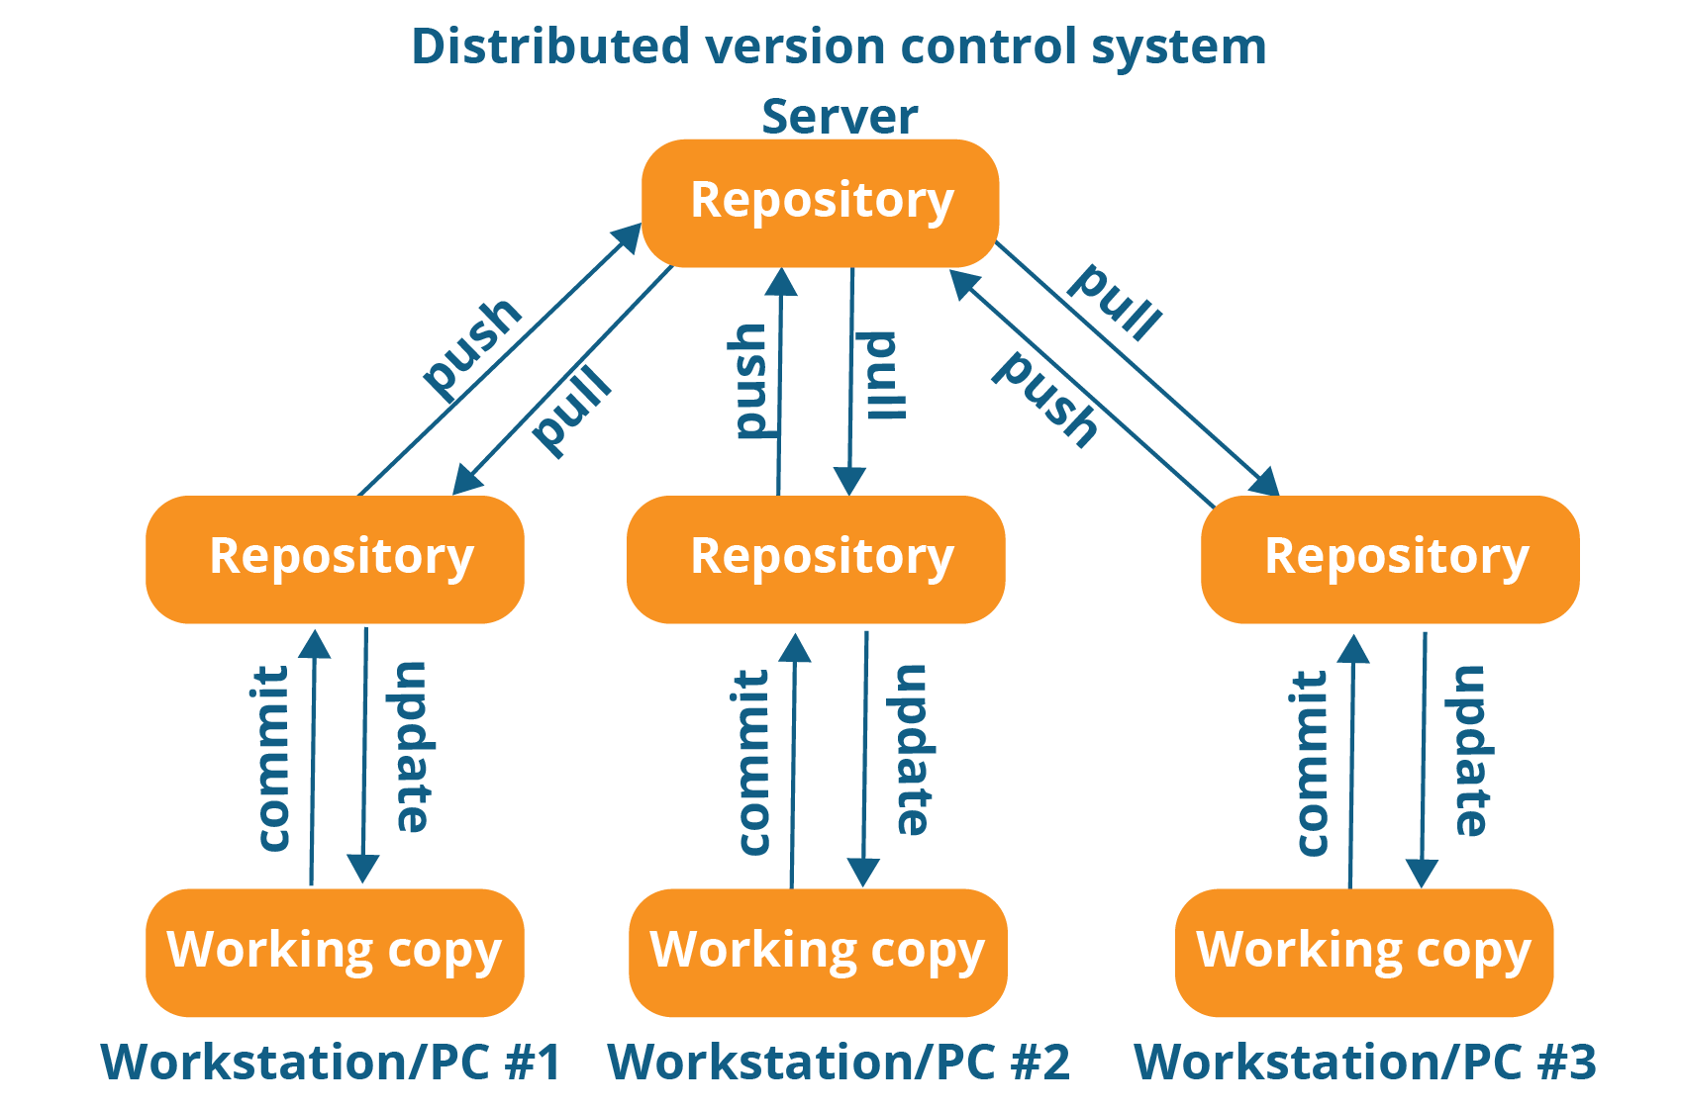

Git uses the distributed model